[GOOGLE EARTH ENGINE](EE01%20Earth%20Engine%20(EE).docx) [APPLICATION PROGRAMMING INTERFACE](EE05%20%20%20The%20EE%20API.docx)

**CONTROLS**

All EE API controls are presented on a single web page in four sections including a **Mapping Panel**. a **Reporting Panel**,

a **Reference** **Panel**, and a **Scripting** **Pane****l**. Note that these sections can be resized

by dragging on the boundaries between them.

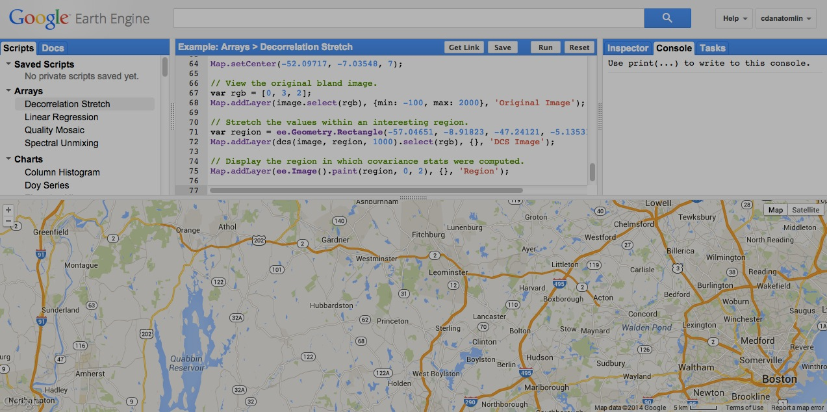 Note too that

this **Help** button

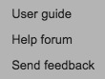can be used to

- access online

**SCRIPTING**

**PANEL**

**MAPPING**

**PANEL**

**REFERENCE**

**PANEL**

**REPORTING**

**PANEL**

documentation,

- participate in an online. forum, or

- send user feedback

to Google.

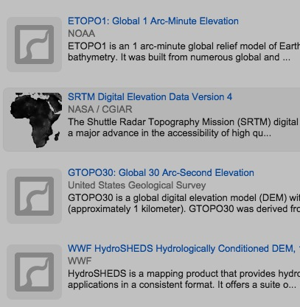

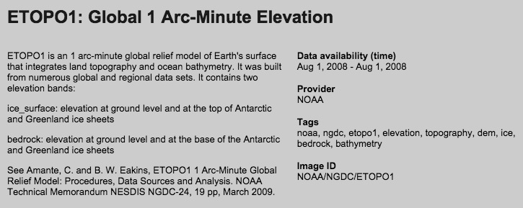

Also note that this **Search Bar** can be used as it is in the GUI:

to locate and provide information on available datasets.

Here, however, it is not be used to load those data.

[GOOGLE EARTH ENGINE](EE01%20Earth%20Engine%20(EE).docx) [APPLICATION PROGRAMMING INTERFACE](EE05%20%20%20The%20EE%20API.docx)

**CONTROLS** IN THE **MAPPING PANEL**

ADD REFERENCE TO THE UPPERLEFT SCREEN-DRAWING TOOLS

The **Mapping Panel** of the API works much like its GUI counterpart and thus much like Google Maps and Google Earth.

Zooming is controlled with this slider bar or by using a mouse’s scroll wheel.

Panning is accomplished by dragging on the screen.

A **Map/Satellite** button toggles between cartographic and photographic displays.

A **Terrain** button adds/removes relief shading from a Map-formatted display

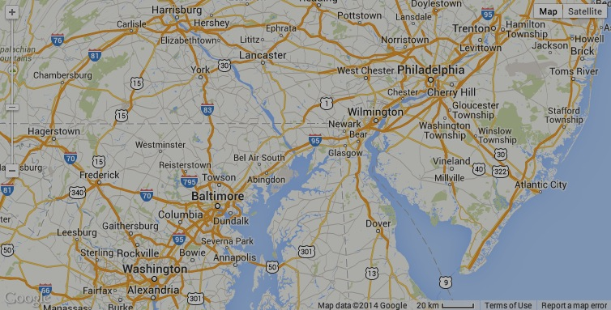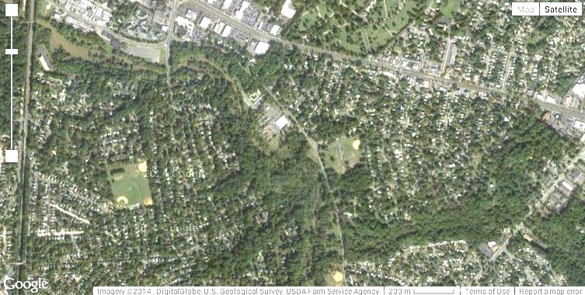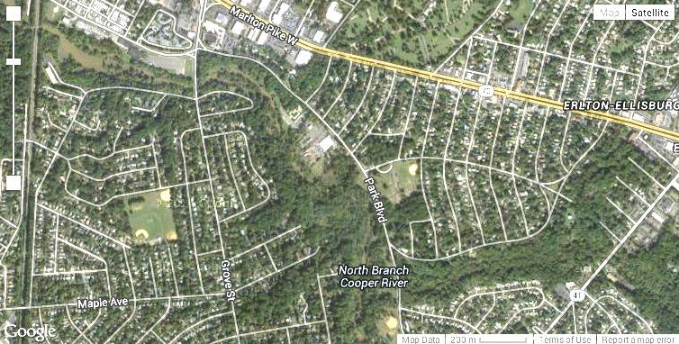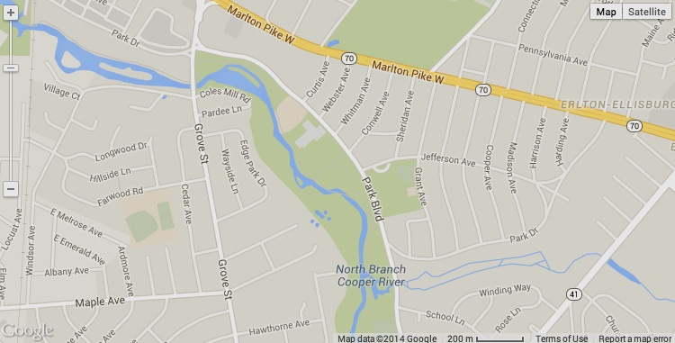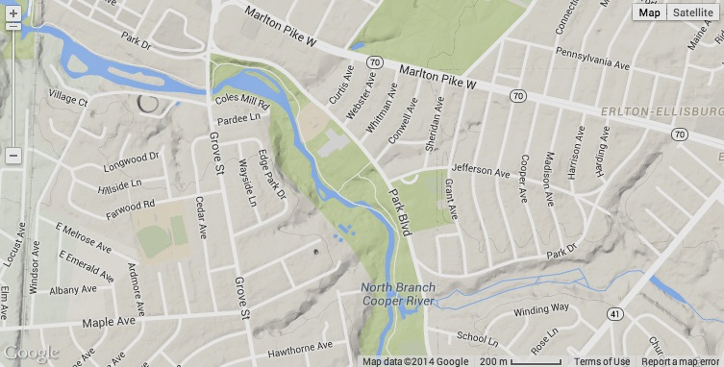A **Labels** button adds/removes labels from a Satellite-formatted display

When multiple layers are displayed,

they are listed by name with slider bars

to control their

translucency

and checkboxes

to control

their visibility.

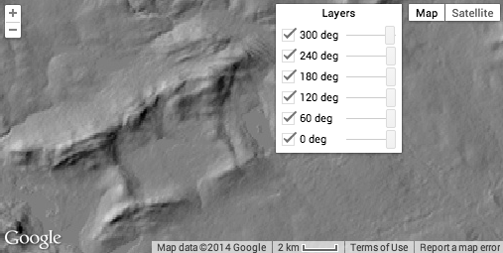

.

Layers are automatically reprojected as necessary,

and some may become invisible when zoomed too far in or out.

Additional control over the presentation of layers in the Display Screen

is exercised only by way of scripts executed through the Program Panel.

[GOOGLE EARTH ENGINE](EE01%20Earth%20Engine%20(EE).docx) [APPLICATION PROGRAMMING INTERFACE](EE05%20%20%20The%20EE%20API.docx)

**CONTROLS** IN THE **REPORTING PANEL**

The **Reporting Panel** presents information on selected elements of data and data-processing activity. It does so by way of three tabs called - **Inspector**,

- **Console**, and

- **Tasks**.

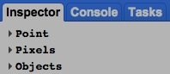The **Inspector** tab reports on whatever location

was most recently clicked on the Display Screen

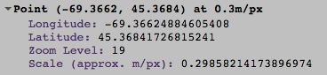This report describes the location’s

- geographical **point**, including its

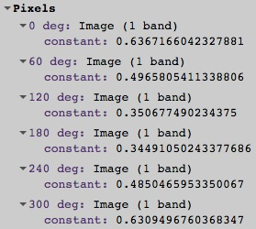- longitude,

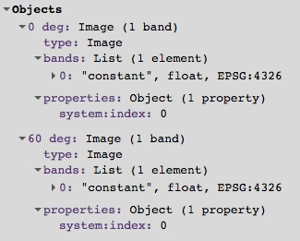 - latitude,

- zoom level, and

- scale (in meters per pixel);

- its **pixel(s)** on whatever layer(s)

is/are currently loaded, including

- layer name,

- type,

- number of bands, and

- value; and

- the full set of **objects** associated with that location.

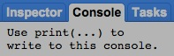The **Console** tab prints whatever messages

may be generated by invoking the **print()**

function when running a script.

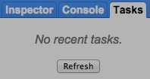And the **Tasks** tab reports on recent batch tasks.

[GOOGLE EARTH ENGINE](EE01%20Earth%20Engine%20(EE).docx) [APPLICATION PROGRAMMING INTERFACE](EE05%20%20%20The%20EE%20API.docx)

**CONTROLS** IN THE **REFERENCE PANEL**

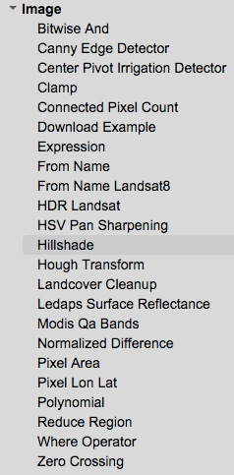The **Reference Panel** of the API plays two rather different roles, and each is associated with one of two tabs respectively labeled

**Scripts** and **Docs**.

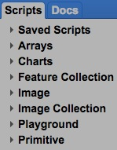A **script** is sequence of JavaScript or Python programming language statements that direct Google Earth Engine to perform a sequence of data-processing tasks. Most of what can be done with the EE API is done by way of scripts, and the **Scripts** tab serves as the repository in for both user-authored and system-supplied scripts. User-authored scripts are listed by name a **Saved Scripts** list that can be opened or closed by clicking on its name. System-supplied scripts are likewise listed by name in one of seven additional lists.

Each of these lists can also be opened or closed by clicking on its

name.

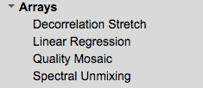

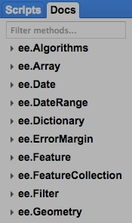

The **Docs** tab presents brief descriptions of the JavaScript

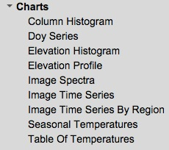methods that are available for use in user-authored scripts.

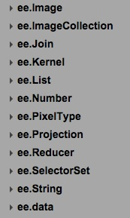These are organized according to the objects with which

those methods are associated.

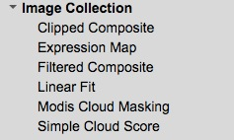

Under **ee.Image**, for example,

these would be some of the

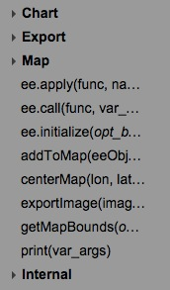methods listed, and this

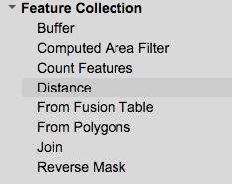 would be one of the

method descriptions.

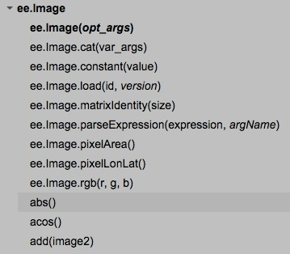

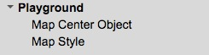

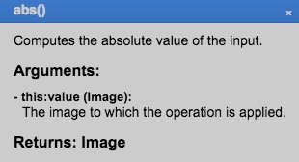

By entering the (full or partial) name of a method here,

you can limit the Docs tab listing to whatever methods

have (fully or partially) matching names.

[GOOGLE EARTH ENGINE](EE01%20Earth%20Engine%20(EE).docx) [APPLICATION PROGRAMMING INTERFACE](EE05%20%20%20The%20EE%20API.docx)

**CONTROLS** IN THE **SCRIPTING PANEL**

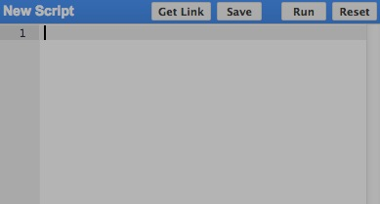

The **Scripting** **Panel** provides for the development, execution, storage,

and distribution of scripts. It does this through the use of

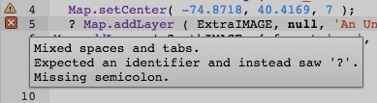

- a **Reset** button that clears the Report Panel and the Display Screen,

- a **Code Sheet** that provides for the editing of a script,

- a **Run** button that executes whatever script is being edited,

- a **Save** button thatsaves the current state of whatever script is being edited.

- a **Get Link** button, thatmakes it possible to share the

current state of whatever script is being edited by reporting the script’s

web address (URL) in the address bar at the top of the EE API window.

Warning and error messages can be consulted by clicking on icons like these that will appear when needed.

Use of the **Code Sheet** often begins with a click on the name of a script in the Scripts tab of the Archive Panel.

That will load the selected script onto the Code Sheet and thereby replace its former content.

Within the Code Sheet, a script can be edited much like it would with any standard text editor.

The **Run** button will attempt to execute the currently loaded script and, in doing so,

will direct any newly generated layers to the Display Screen and any other output

(including error messages) to the Console tab of the Report Panel.

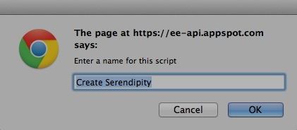

It is for this reason that the **Reset** button is provided here to clear the Report Panel.

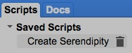

The **Save** buttonstores the current content of the Code Sheet by soliciting a name

for the saved script, which will then be listed under Saved Scripts in the Scripts tab

of the Archive Panel. A saved script can later be deleted by clicking here.

The **Get Link** buttonpurportedlygenerates and reports a unique URL

with which share the current state of whatever script is being edited.

In the current version of the EE API, however, it seems to have no effect.